Minnesota Council for HIV/AIDS Care and Prevention (MCHACP) Meeting

Tuesday, April 11, 2023
9:00 a.m. – 11:00 a.m.
Hybrid Meeting

Microsoft Teams meeting
Committee Members Present:
Jay Orne | John Vener, MD
Danielle Brantley | Dennis Anderson
Moua Xiong | Tesha Johnson
Doug Peterson | Megan Higdon
Calvin Hillary Hylton (council co-chair) | Talaya Banks
Ellen Ryan | Gage Urvina
Alejandro Aguilera | Lesa Nelson
Angela Reed | Stephen Jensen
Annalise Jackson | Alissa Fountain
Julian Hines | Tristian Sparks
Kevin Sitter | Shea Amaro
Tyrie Stanley (council co-chair) | James Velek
Joe Amrhein (council co-chair) | Larry McPherson
Mohamedkader Mohamed
Zoe Neba Caboret
Committee Members Absent:
Nikki LeClaire | Charlene Leach
Terri Wilder
Guests:
Cody Raasch | Pat Reymann (Council Parliamentarian)
Matt Toburen (Aliveness Project) | Jessica Weiser
Angela North (Clare Housing) | James McMurray
Hennepin County (Part A) Representative: | DHS (Part B) Representative:
Brenda Senyana | Thomas Blissett
Eriika Etshokin
MDH (Prevention) Representative: | MDH (Surveillance) Representative:
Peggy Darrett-Brewer | Hannah Kass-Aten
Japhet Nyakundi | Anna Bosch
Jose Ramirez | Quay Catalpa
MCHACP Staff:
Audra Gaikowski, coordinator | Emily Murphy, minutes
Carissa Weisdorf
Quorum Present? Yes

Welcome and introductions
- Meeting was called to order at 9:02 a.m. Introductions were made.

The minutes from the March 14 meeting were reviewed and approved with the addition of John Vener being added to the list of committee members who were in attendance.

The agenda for the meeting was approved as printed.

Recipient Report
- Prevention- 2022 financial report, PrEP update, Syringe Services Programs (SSPs) update, and Early Intervention Services (EIS) testing update
Peggy Darrett-Brewer, Anna Bosch, Quay Catalpa, Japhet Nyakundi, Jose Ramirez, Minnesota Department of Health HIV/STD/TB
  - MDH presented a PowerPoint titled, MDH Prevention Unit Updates (this was emailed to council members on 4/11/2023).
  - Jose Ramirez provided Program Financial updates:
      - HIV Early Intervention Service (EIS) Programs (13 funded agencies)
        - MDH Funding Source: DHS (rebate revenue)
        - 2022 Awarded Amount: $1,385,550
        - 2022 Spent Funds: $1,049,371
        - Percent of Funds Spent: 75.7%
      - HIV Prevention Projects – HIV Testing & Syringe Service Programs (15 funded agencies)
        - MDH Funding Source: Federal/State
        - 2022 Awarded Amount: $1,766,246
        - 2022 Spent Funds: $1,620,227
        - Percent of Funds Spent: 91.7%
      - Clinical EIS/PrEP (2 funded agencies)
        - MDH Funding Source: Federal/State/Rebate
        - 2022 Awarded Amount: $95,000
        - 2022 Spent Funds: $85,775
        - Percent of Funds Spent: $90.3%
      - Reasons why there were unspent funds for 2022
        - Frequent staff turn over
        - COVID reassignments differ from programmatic goals
        - Oversaturation of programs in specific demographics
        - Limited outreach/harsh winter weather conditions
        - Multiple outbreak responses required (COVID, M-Pox, HIV)
        - Encampment sweeps- causes loss of medication, identification, other important information.
      - Partner Services Program (6 funded agencies):
        - MDH Funding Source: Federal
        - 2022 Awarded Amount: $1,313,343
        - 2022 Spent Funds: $765,964
        - Percent of Funds Spent: 58.3%
    - Quay Catalpa provided an HIV Testing Update:
      - EIS and PS18-1802 Testing Results for 2022 are as follows:
Program Announcement | Negative: | Positive: | Total Tests Performed:
Early Intervention Services | 2,172 | 14 | 2,186
PS18-1802: | 3,057 | 18 | 3,075
Totals: | 5,229 | 32 | 5,271
      - HIV Testing Programs: 2022 Updates – Challenges
        - Continued COVID restrictions and redeployment for County Grantees.
        - Encampment sweeps
        - Harsh winter conditions
        - False reactive results
        - Staff turnover
        - Limited gender categories within EvaluationWeb (defined by the federal government).
      - HIV Testing Programs: 2022 Update
        - Expanded community testing from previous 2 years as program restrictions related to COVID019 started lifting.
        - Strengthened interagency collaboration through Metro and Duluth HOPE Group and SSP Network.
        - MDH and Grantee organizations co-hosted Community HIV Testing Event in North Minneapolis.
          - Over 100 people received testing
          - Over 300 people received wrap around services, including onsite COVID vaccination, syringe exchange, linkage to positive care, and syphilis testing.
    - 2023 EIS Programs and Grantees include:
      - BIPOC MSM Metro – Black MSM
        - Clinic 555
        - African American AIDS Task Force
      - BIPOC MSM Metro – Latino MSM
        - Minnesota Community Care
      - Black Women Metro
        - Sub-Saharan Youth and Family Services
        - Annex Teen Clinic
        - Youth and AIDS Project
      - Transgender Metro
        - Aliveness
        - Minnesota Community Care
      - PEH/Unstably Housed Metro
        - Native American Community Clinic
      - Greater Minnesota
        - Lutheran Social Services
        - Planned Parenthood
      - Training Updates for 2023
        - Return to in-person quarterly HIV Tester Trainings
        - Duluth training took place Feb 6th and 7th. Metro training took place March 1st and 2nd.
        - Next training will be in-person in May. HIV Testing Trainings - MN Dept. of Health (state.mn.us)
    - Anna Bosch provided an update on the Syringe Services Program (SSP) 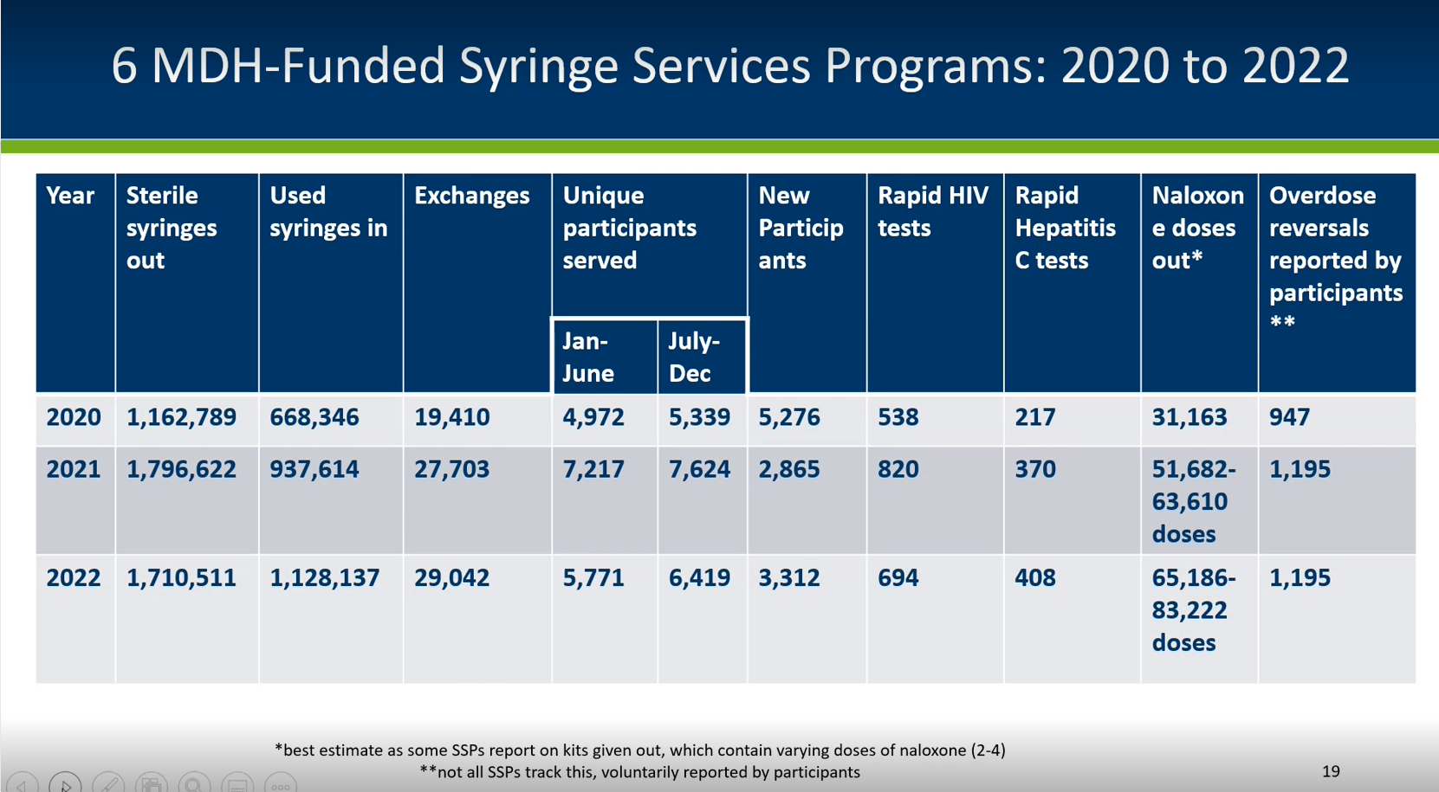

- Many participants of SSPs are people experiencing homelessness, so the programs meet people where they are.
  - In mobile vehicles
  - Delivery-based
  - Pop-ups
  - At other service locations
  - Brick and mortar
  - Some via mail
  - All seasons
- SSP 2022 Updates:
  - Continued provision of services in response to community insights/needs.
  - Collaboration: tribal partnerships, pharmacy partnerships, ongoing communication with law enforcement, partnerships with Corrections.
  - Continued engagement in HIV and syphilis outbreak response in both metro area and Duluth area.
  - Fentanyl test strips utilization leading to associated behavior changes based on test results: not using, changing mode of use, not using alone, or using less.
- Xylazine is a tranquilizer that is now present in Minnesota and is usually found with fentanyl. Xylazine overdose does not respond to naloxone and its test strips are considered illegal paraphernalia in Minnesota.
- SSP 2022 Challenges:
  - Encampment sweeps
  - Syringe litter complaints
  - Law enforcement encounters
  - New trends in substances – xylazine concerns
  - High demand for safer snorting/smoking supplies, funding won’t cover
  - Balancing minimal funding for supplies and providing needs-based distribution
  - False reactive results
  - Requests for de-escalation training
  - Unique participant tracking challenges
  - Pharmacy syringe access challenges
- Other updates for 2023
  - Continued/increased education/engagement with homeless service providers for SSPs
  - Ongoing education/discussion around xylazine
  - Lots of discussion, interest in overdose prevention centers
  - Governor’s budget proposal includes funding for SSPs
  - Collaborative workgroup on HR policy and legislation
- MDH IDEPC-Funded Syringe Service Programs for 2023-2024 are Harm Reduction Sisters, Southside Harm Reduction Services, North Point In ‘n’ Out, Clinic 555, Rural AIDS Action Network, Native American Community Clinic.
- MDH is creating a landing page on its website that will show up-to-date syringe exchange calendars for the Twin Cities. The calendars are currently posted on Rainbow Health and Southside Harm Reduction’s websites.
- Japhet Nyakundi will present at the next month’s meeting due to time constraints.

- Part A: Jonathan Hanft, Hennepin County Ryan White Program (Written update)
- Full FY 2023 Part A grant award expected in April
  - Plan to bring proposed allocations changes to PAC in April
  - Council approval of adjustments at May meeting
- FY 2023 core medical services expenditure waiver approved
  - Allows the Part A recipient to expend greater than 25% of funds allocated to services on support services
- Upcoming Part A reports to HRSA/HAB
  - FY 2022 Annual Progress report due May 29
- HIV outbreak update from MDH Website
  - 169 cases are associated with the Hennepin/Ramsey outbreak; 1 new case added since last month.
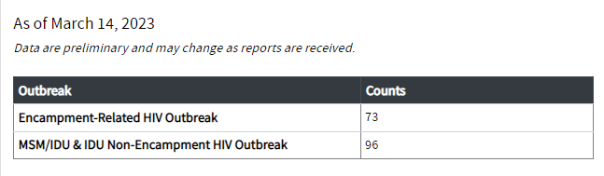
  - 35 cases associated with the Duluth area outbreak; No new cases since last month.

- Part B: Thomas Blissett, Minnesota Department of Human Services HIV Supports
  - See written update.

- Committee reports
    - Executive and Co-chair Update
- Reviewed council and committee operations evaluation result and the religious holiday calendar against the FY2023 meeting schedule.
- Heard reports from each standing committee, council co-chairs, recipients, and council staff.

    - Community Voices Committee (CVC)
- Received an HIV legislative update from Matt Toburen.
- Reviewed the FY2023 workplan and discussed topics and emerging issues to discuss in the coming year.
- Planning continues for the World AIDS Day Breakfast on December 1.
- Hosted the annual committee co-chair election and forwards 1 action item for the CVC co-chair election.
- The next meeting is on Monday, May 8th from 4-6pm at the Aliveness Project.
  - Action Item: CVC co-chair election
    - Danielle Brantley read the rationale and moved on behalf of the CVC that Danielle Brantley and Tristian Sparks are elected to serve as co-chairs of the Community Voices Committee.
    - The election will be by ballot and ballots will be distributed online for those participating virtually and a physical ballot for those online. The results will be stated in unfinished business.
    - Disparities Elimination Committee (DEC)
  - Finalized a script and continued planning for a mental health provider discussion to be held on May 18th from 9:30am-11:30am, in-person at Health Services Building (virtual option available).
  - Reviewed the FY2023 workplan and discussed emerging issues to focus on in the upcoming year.
  - Hosted the annual committee co-chair election and forwards 1 action item for the DEC co-chair election.
  - Action Item: DEC co-chair election
    - Jay Orne read the rationale and moved on behalf of DEC that Sarah Schiele and Jay Orne are elected to serve as co-chairs of the Disparities Elimination Committee.
    - The election will be by ballot and ballots will be distributed online for those participating virtually and a physical ballot for those online. The results will be stated in unfinished business.
    - Needs Assessment and Evaluation Committee
- Reviewed the biannual council and committee operations evaluation results.
- Continued discussions of HIV care and prevention in the Hennepin County corrections system.
- Reviewed the FY2023 workplan and discussed emerging issues to focus on in the upcoming year.
- Held the annual committee co-chair election and forwards 1 action item for the Needs Assessment and Evaluation committee co-chair election.
  - Action Item: Needs Assessment and Evaluation committee co-chair election
    - Tyrie Stanley read the rationale and moved on behalf of Needs and Assessment Committee that Joe Amrhein and Alejandro Aguilera are elected to serve as co-chairs of the Needs Assessment and Evaluation Committee.
    - The election will be by ballot and ballots will be distributed online for those participating virtually and a physical ballot for those online. The results will be stated in unfinished business.
    - Planning and Allocation Committee
  - Did not meet.
    - Membership and Training Committee
- Reviewed attendance and selected committee members to contact council members who had missed meetings.
- Reviewed the FY2023 workplan and discussed emerging issues to focus on in the upcoming year.
- Reviewed the FY20233 meeting schedule against religious holidays.
  - Action Item: Membership and Training Committee co-chair election
    - Stephen Jensen read the rationale and moved on behalf of the Membership and Training Committee that Stephen Jensen be elected as co-chair of the committee.
    - The election will be by ballot and ballots will be distributed online for those participating virtually and a physical ballot for those online. The results will be stated in unfinished business.

- Council Staff Report
- Audra was asked to share the Guide To LGBTQ+ Elder Health Care: Statistics & Resources (retireguide.com)
- The Council training plan is complete and was reviewed by Membership and Training Committee. The plan is on the Council website.
- Audra will send out a survey to members regarding preferences for meeting formats.
- Audra will be on PTO from May 3rd through May 12th. Jeremy, the new admin assistant will be available to provide any support needed.

- Data training: Epidemiology terms Hannah Kass-Aten, Minnesota Department of Health
  - Hannah presented a PowerPoint titled MCHACP Epi Terms Module April 2023 (this was emailed to council members on 4/11/2023)
  - Epidemiology is:
    - The study of health and diseases in population and communities.
    - Description of patterns of diseases concerning individual person characteristics, geography or place, setting, and time.
    - Analyses to understand what a particular disease or infection looks like.
  - The purpose of Epidemiology is to:
    - Monitor disease incidence and prevalence in a population.
    - Monitor treatment outcomes for people living with HIV
    - Identify changes in trends over time and (re)emerging populations
    - Target prevention and care interventions.
    - Allocate funds for health and social services.
  - Why we should care about statistics:
    - The number of people living with HIV/AIDS impacts both prevention and care services.
    - Higher concentrations of infection in highly impacted communities makes it more likely that transmission will occur, even with the same behaviors.
    - Looking at new cases and genetic sequences of HIV infections helps us identify emerging trends in the outbreak, such as trends related to people who inject drugs.
  - Core Principles of Epidemiology
    - Understand who is described in the statistic (entire state or subgroups within that)
    - Understand what the statistic is (number of cases, rates of infection, retention in care)
    - Understand when the statistic is calculated (one year, multiple years).
  - Incidence vs. Prevalence
    - Prevalence = new and cumulative cases currently infected within a defined area or population.
    - Incidence = New cases reported to the health department during a given time period.
      - Incidence in the context of HIV only refers to cases we know are newly diagnosed and reported to the health department since it is possible for people to live with the infection for a while without being diagnosed.
    - Cases vs. Rates
      - Cases, also called counts or numbers, are an absolute number that describes how frequently a disease or infection occurs.
      - Rates are a relative number that describes how frequently a disease or infection occurs in relation to a defined “at risk” population.
    - The HIV Continuum of care moves through the following stages:
      - Diagnosed with HIV: received a positive HIV test that has been reported to MDH
      - Linked to Care: measure of time between date of HIV diagnosis and initial CD4/viral load results, does not reflect any appointments after that time.
      - Engaged or retained in care: at least one CD4 or viral load result reported MDH within a calendar year.
      - Achieved Viral Suppression: most recent viral load reported to MDH within the calendar year was less than 200 copies/mL.
    - A Risk Factor is a behavior, condition, or other factor that increases the likelihood of HIV infection.
    - A Transmission Category is the specific risk factor most likely to have resulted in HIV transmission.
    - Late Testers are individuals who have a stage 3 HIV infection (AIDS) at time of diagnosis or within one year after diagnosis – likely infected years before they were diagnosed.
    - Cluster: a group of cases in a specific time and place that might be more than expected. (It may or may not become an epidemic or outbreak).
    - Epidemic or outbreak: disease or infection occurring in a population or community that is in excess of what is expected at a given time and place.
    - Endemic: disease or infection is present in a population at all times and places.
    - Pandemic: disease or infection that spreads across regions (like COVID and SARS).
    - MCHACP uses data from eHARS, CAREWare, and EvaluationWeb.

- Conflict of interest training Audra Gaikowski, Council Coordinator
  - HRSA requires planning councils to employ a variety of strategies to minimize conflict of interest and its potential adverse effects.
    - See the Part A Manual | TargetHIV for additional information about managing conflict on interest on planning councils.
  - The Council manages conflict of interest through 4 methods: annual training on the topic, asking everyone to sign a conflict of interest form, a checklist for co-chairs to follow to help mitigate conflict of interest, and a defined process for mitigating these conflicts.
  - It would be considered a conflict of interest (COI) if you or a close relative is employed, sits on the board of, or is a paid consultant to an agency that receives Part A, Part B, or Part B rebate funding and is a potential to benefit directly from a decision made by the Council.
  - Conflict of interest establishes trust and credibility in the community. It is not about you as a person, it is a condition of ‘wearing multiple hats.’
  - You are not in conflict of interest if you are part of a broad category of people; therefore, unaligned consumers are not in COI.
  - You are not in conflict of interest if the council is voting on a ‘slate.’
  - COI is important because it establishes:
    - Credibility with the broader community.
    - Responsibility for funding and the interests of consumers.
    - Clarity for all council members.
    - Accountability HRSA.
  - MCHACP COI Procedure and Process
    - Complete the COI form every year
    - If you know in advance of a meeting that you are in COI on an agenda item, contact the staff or co-chair.
    - If you do not know this until the meeting, declare COI at the meeting and decide with co-chairs and staff what to do.
    - If you are aware that someone else is or may be in COI you should raise the issue to the council, staff, or chair.
    - If you or a co-chair identifies that you are in COI you do not need to specify all the details.
    - You will leave the meeting after a motion is made and before debate and voting on the issue begins.
    - You will be notified when the vote has been taken so you can return to the meeting.

- Unfinished/New Business
  - Tyrie Stanley shared the teller’s report (note that the report was read inaccurately at the meeting because there was one illegal vote cast by a non-council member that should not have been included in the total number of votes. However, the teller’s report seen below is accurate):
    - Community Voices Committee: The number of ballots cast is 19. The number needed for election (a majority) is 10. There was 1 illegal vote cast. No debate. VOTE: Danielle Brantley (18), Tristian Sparks (18).
    - Disparities Elimination Committee: The number of ballots cast is 19. The number needed for election (a majority) is 10. There was 1 illegal vote cast. No debate. VOTE: Sarah Schiele (18), Jay Orne (18).
    - Needs Assessment and Evaluation: The number of ballots cast is 19. The number needed for election (a majority) is 10. There was 1 illegal vote cast. No debate. VOTE: Joe Amrhein (19), Alejandro Aguilera (19).
    - Membership and Training Committee: The number of ballots cast is 19. The number needed for election (a majority) is 10. There was 1 illegal vote cast. No debate. VOTE: Stephen Jense (18).

- Open Forum
  - Tyrie clarified a question about Council voting bylaws with the parliamentarian.

- Announcements
  - None

- Adjourn
  - Meeting adjourned at 11:06am

Meeting Summary:
- MDH HIV/STD/TB provided prevention, 2022 financial report, PrEP, SSPs, and EIS testing updates.
- Part A and Part B updates were shared via written format.
- Committee updates were reported.
- Committee co-chair elections were held for Community Voices, Disparity Elimination, Membership and Training, and Needs Assessment and Evaluation committees.
- MDH gave a presentation on Epidemiology terms and data.
- The Council coordinator lead a conflict of interest training.

Documents distributed before the meeting:
- March 14, 2023 MCHACP minutes
- 2023.04.11 action item CVC co-chair election
- 2023.04.11 action item DEC co-chair election
- 2023.04.11 action item M&T co-chair election
- 2023.04.11 action item NA&E co-chair election
- 2023.04.11 MCHACP Agenda
- FY2023 Religious Holidays List

Documents displayed during the meeting:
- Prevention, 2022 financial report, PrEP, SSPs, and EIS testing update PowerPoint presentation slides
- Epidemiology Terms presentation slides
- Conflict of Interest and Policy Management slides
- Report of the Tellers – Committee co-chair elections

Documents distributed after the meeting:
- Part A Update 2023.04.11

EM/JS/ag

